Abstract

提出一种结合神经网络和基于张力的图形切割方法来精确提取肾脏和肾动脉的全自动分割方法。首先，我们使用卷积神经网络定位肾脏区域，并用基于张力的图像切割方法提取微小的肾动脉。然后我们生成一个Voronoi图，以分叶状肾和肾动脉为基础估计肾血管优势区域。

we segment the kidney regions with a 3D U-Net-like fully convolutional network (FCN) architecture. U-Net architecture

Our network is based on previous 3D U-Net-like architecture

we introduce spa-tial position information into 3D U-Net-like architecture to impose the spatial information of each cropped sub-volume into our FCN architecture. Our proposed network is illustrated in Fig. 2. The back-bone U-Net-like structure, which is based on a previous work

Inspired by the work of Chen et al. (2017), we introduce spa-tial position information into 3D U-Net-like architecture to imposethe spatial information of each cropped sub-volume into our FCN architecture.

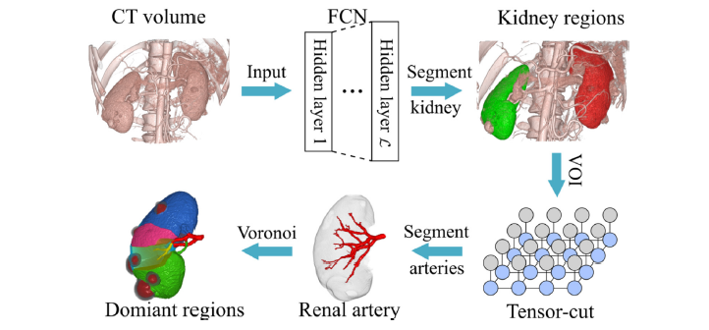

TrainingIn this work, the input volume size of our network is fixed toNx Ny Nz. At each epoch, n sub-volumes are cropped from theoriginal CT volume and fed to the neural network.

TrainingIn this work, the input volume size of our network is fixed toNx Ny Nz. At each epoch, n sub-volumes are cropped from theoriginal CT volume and fed to the neural network.